**TASK 2**

INSERT INTO Event (event_id, event_name, event_date, ticket_price, available_tickets, venue_id, seat_capacity) VALUES

(1, 'Rock Concert', '2025-05-15', 2000, 50, 1, 20000),

(2, 'Jazz Night', '2025-06-10', 1500, 30, 2, 12000),

(3, 'Football Cup', '2025-07-20', 1800, 100, 3, 18000),

(4, 'Music Festival', '2025-08-05', 2500, 20, 4, 25000),

(5, 'Comedy Show', '2025-09-12', 1200, 60, 5, 10000),

(6, 'Movie Premiere', '2025-10-25', 1600, 40, 6, 15000),

(7, 'Basketball Championship', '2025-11-08', 2200, 80, 7, 17000),

(8, 'Cricket Cup', '2025-12-14', 1900, 70, 8, 22000),

(9, 'Magic Show', '2026-01-18', 1300, 90, 9, 8000),

(10, 'Tech Expo', '2026-02-22', 1100, 25, 10, 14000);

1.TO INSERT AT LEAST 10 SAMPLE RECORDS INTO EACH TABLE

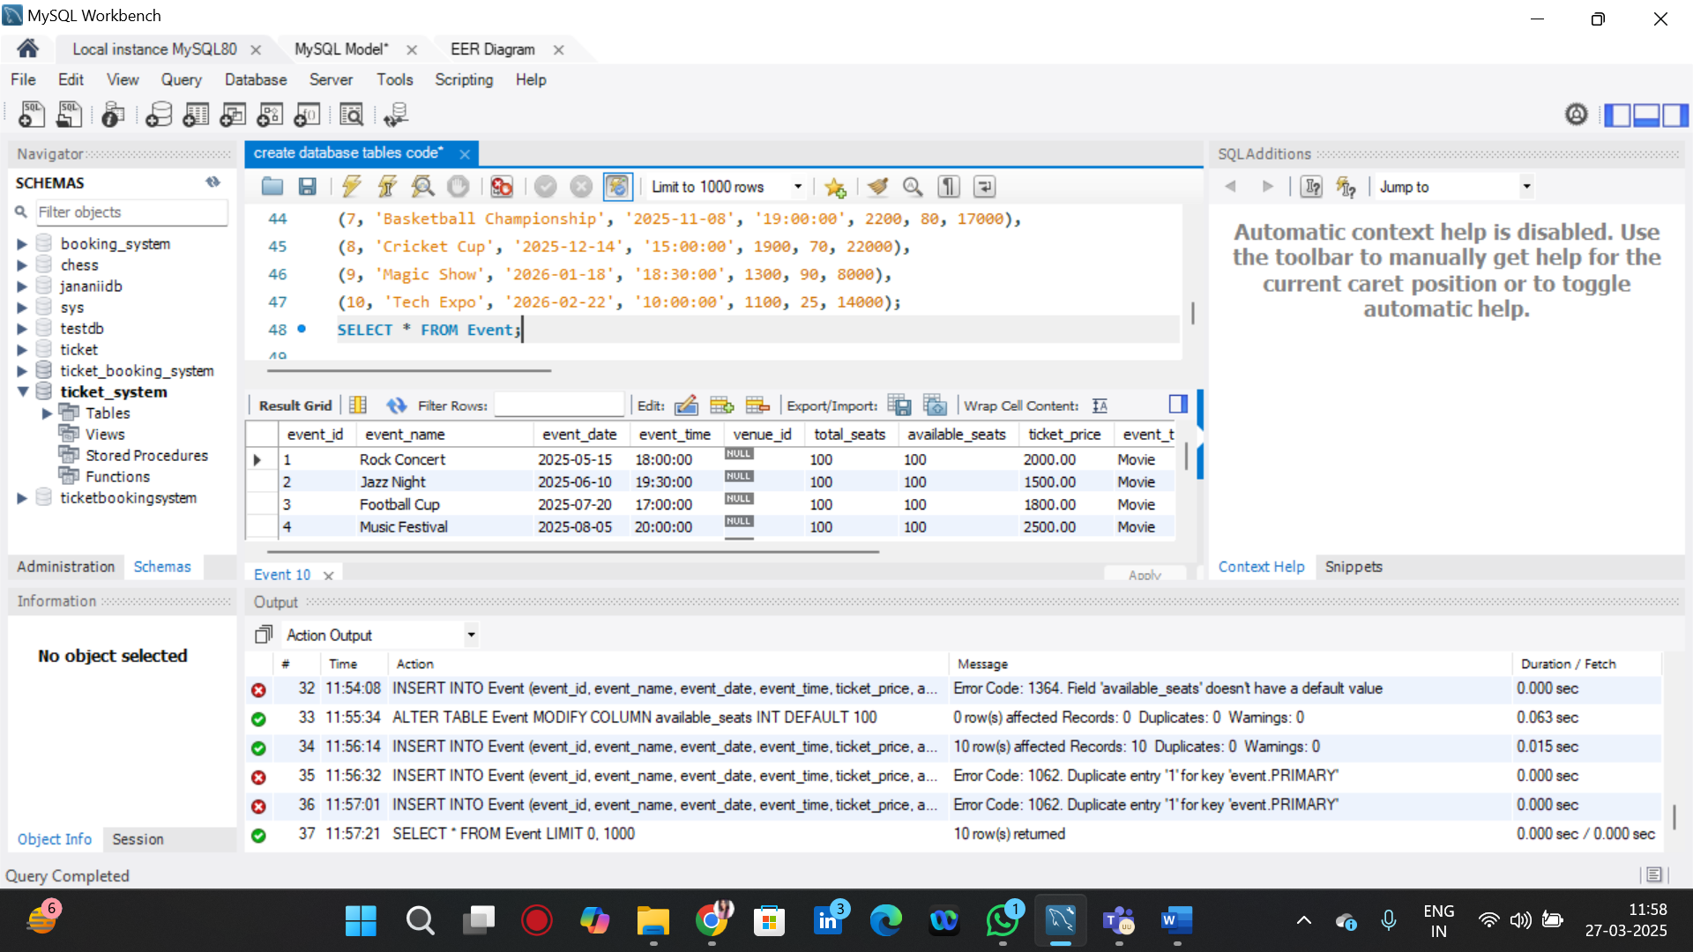

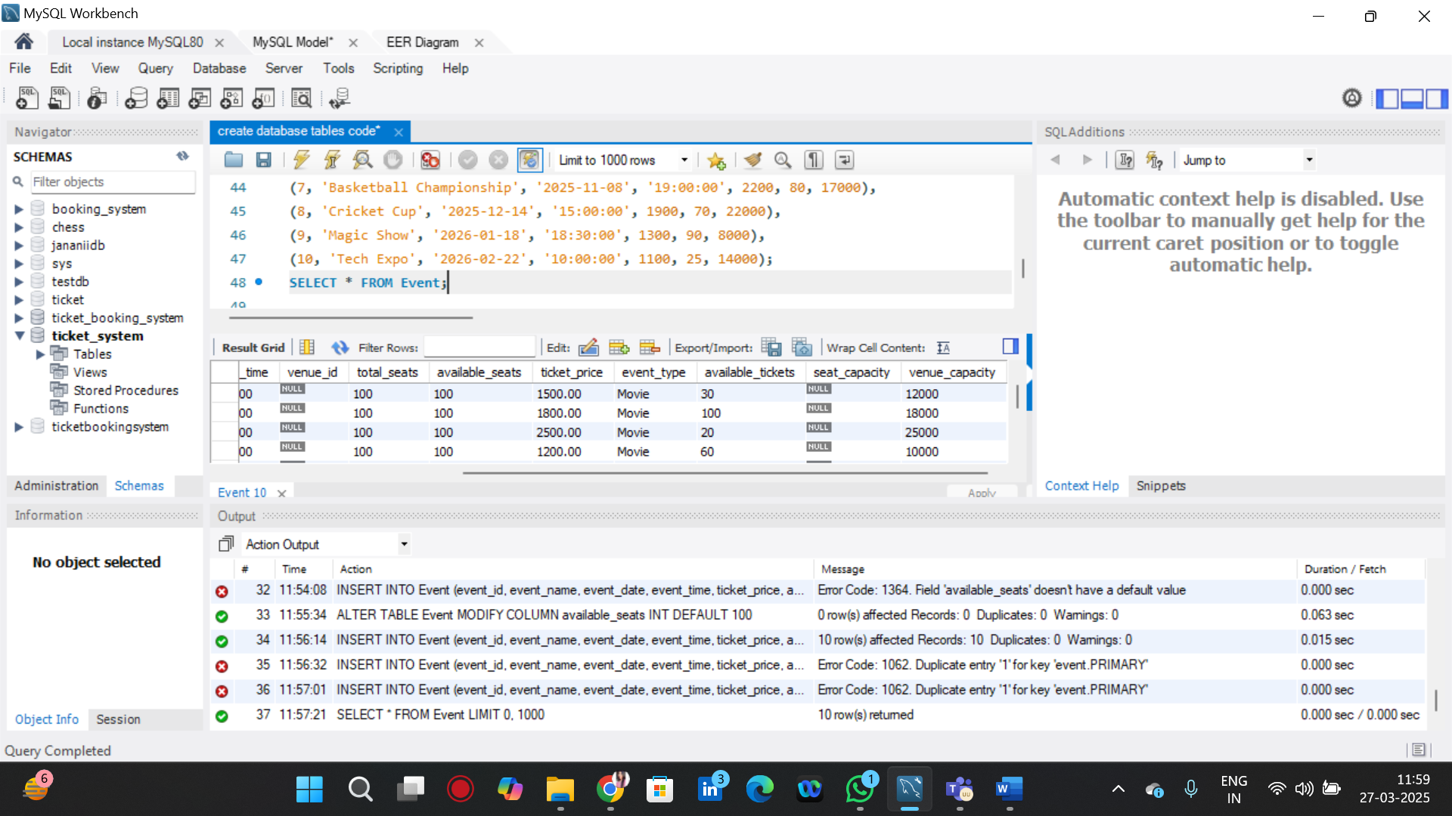

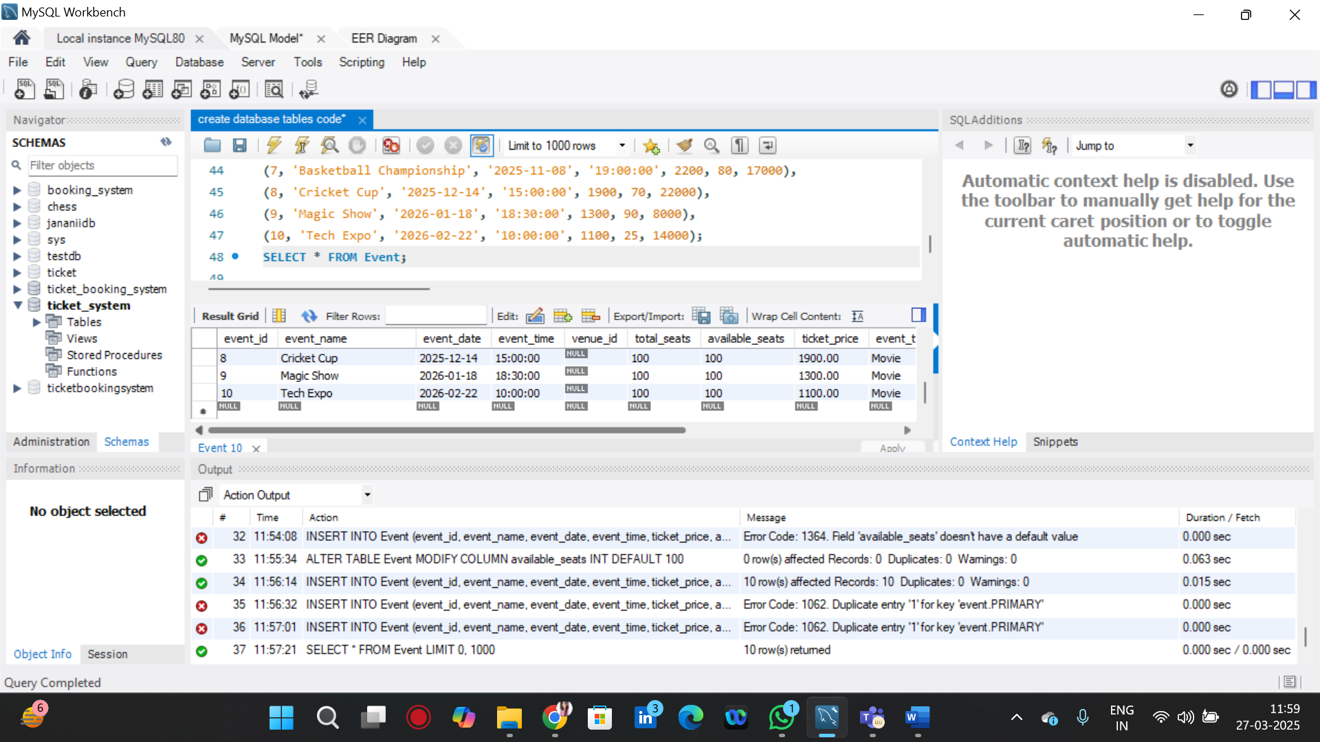

INSERT INTO Customer (customer_id, customer_name, phone_number, email) VALUES

(1, 'John Doe', '9876543000', 'john@example.com'),

(2, 'Jane Smith', '9876543100', 'jane@example.com'),

(3, 'David Miller', '9876543200', 'david@example.com'),

(4, 'Emma Wilson', '9876543300', 'emma@example.com'),

(5, 'Michael Brown', '9876543400', 'michael@example.com'),

(6, 'Sophia Davis', '9876543500', 'sophia@example.com'),

(7, 'Chris Johnson', '9876543600', 'chris@example.com'),

(8, 'Olivia Martinez', '9876543700', 'olivia@example.com'),

(9, 'Daniel Taylor', '9876543800', 'daniel@example.com'),

(10, 'Sarah Anderson', '9876543900', 'sarah@example.com');

SELECT * FROM Customer;

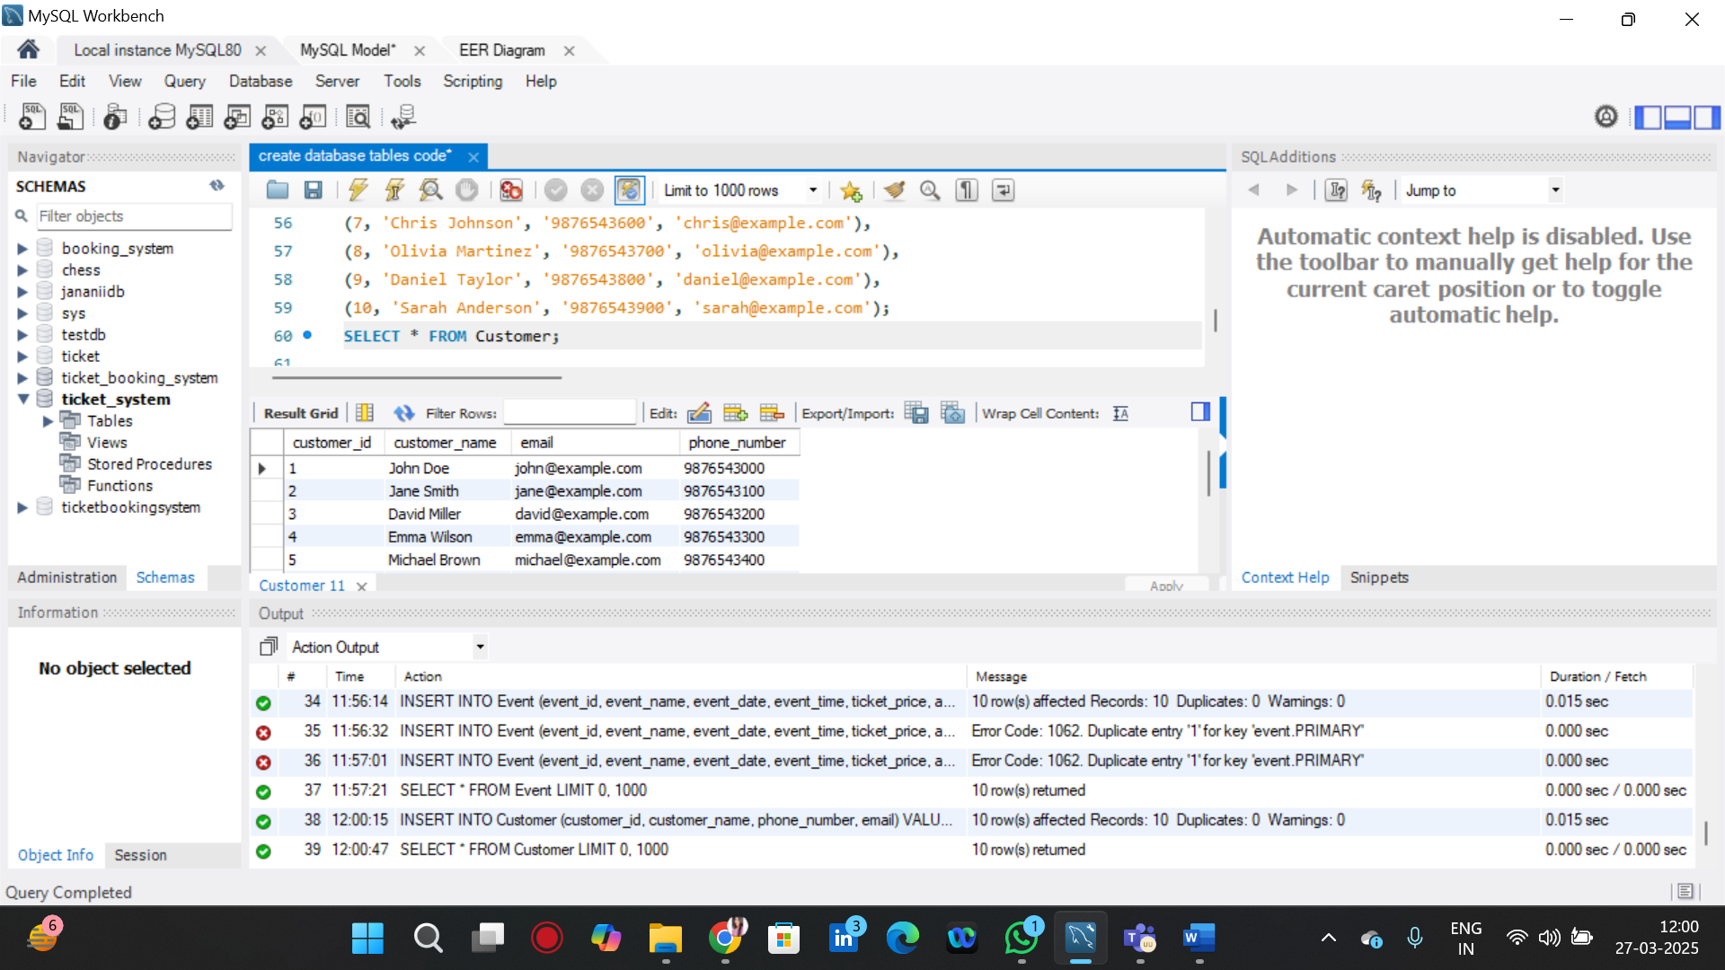

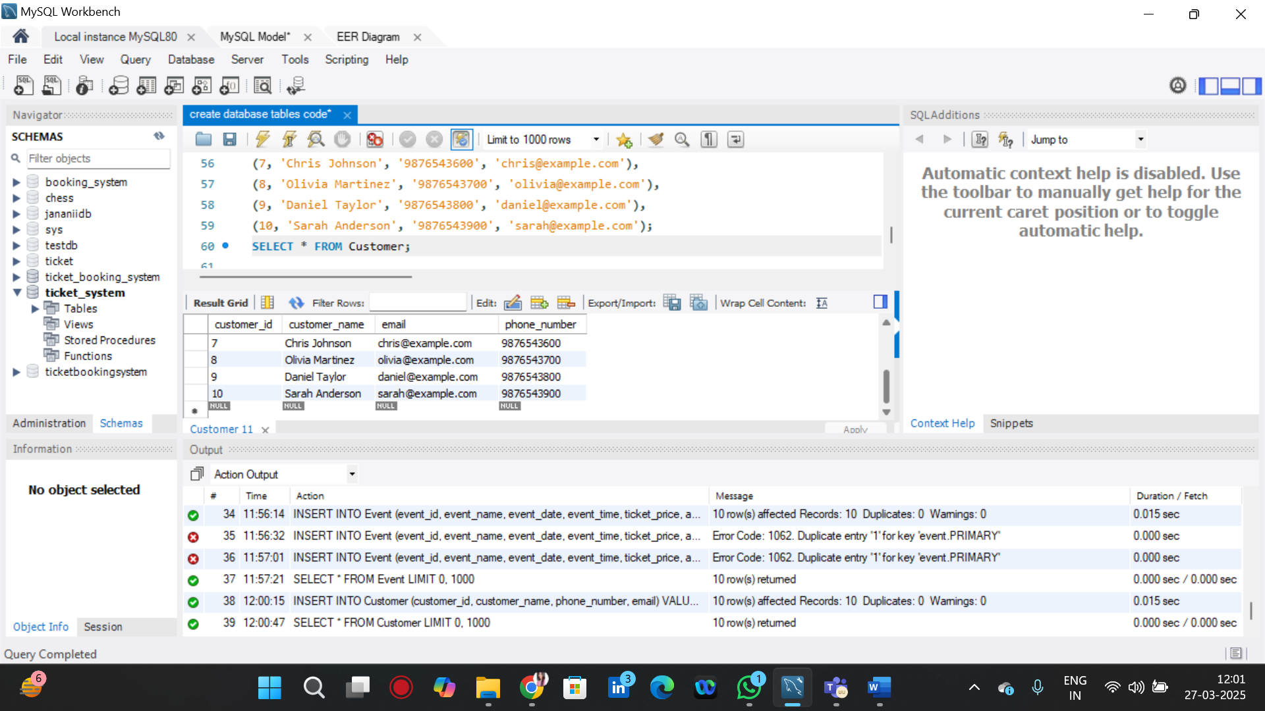

INSERT INTO Venue (venue_id, venue_name, address) VALUES

(1, 'Grand Arena', '123 Main Street, New York'),

(2, 'Skyline Stadium', '456 Elm Street, Chicago'),

(3, 'Sunshine Auditorium', '789 Broadway, Los Angeles'),

(4, 'Central Park Hall', '321 Pine Street, Houston'),

(5, 'Metropolitan Hall', '567 Oak Street, San Francisco'),

(6, 'Ocean View Stadium', '876 Beach Avenue, Miami'),

(7, 'Golden Dome', '234 Maple Avenue, Seattle'),

(8, 'Starlight Theater', '432 Willow Road, Dallas'),

(9, 'Majestic Square', '654 Cedar Lane, Boston'),

(10, 'Silver Stage', '987 Birch Road, Philadelphia');

SELECT * FROM Venue;

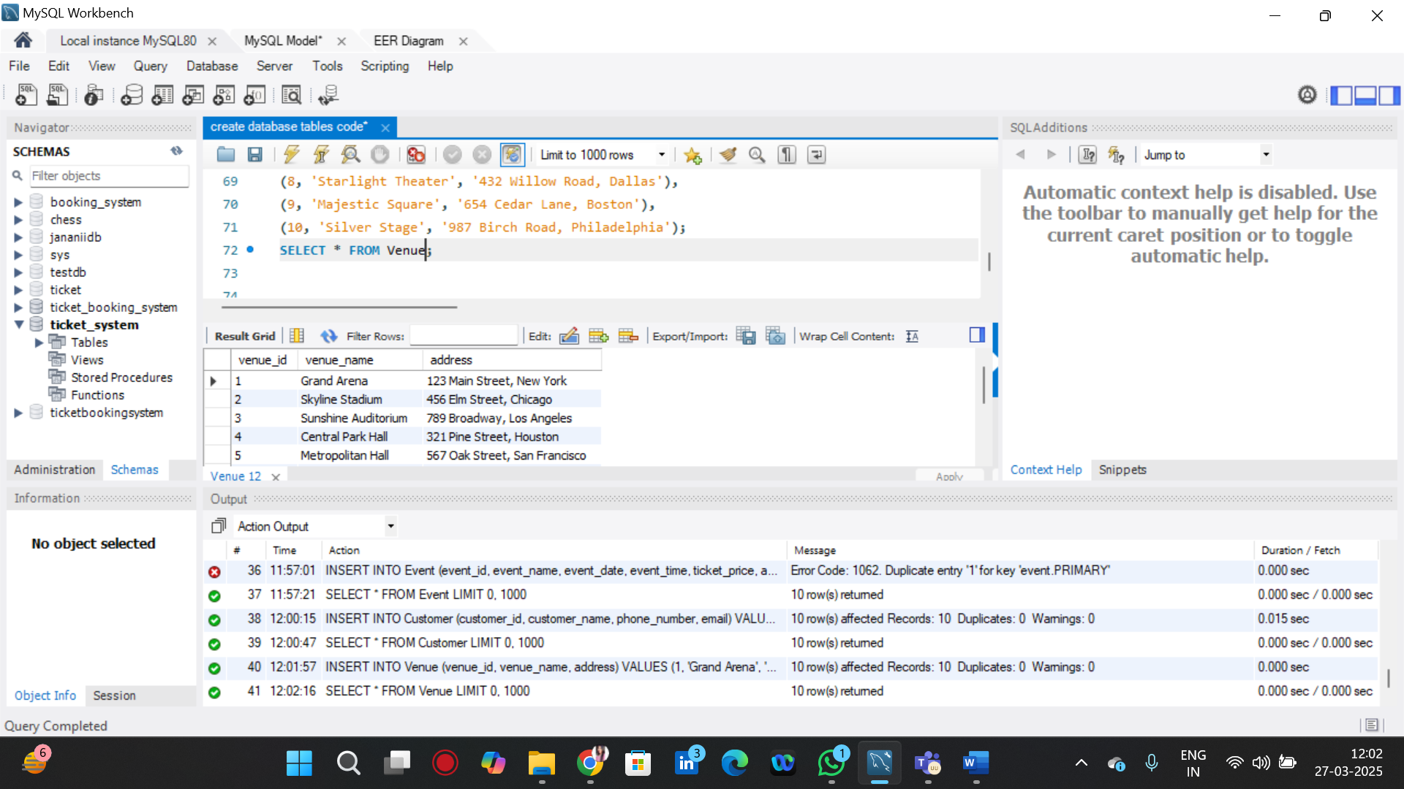

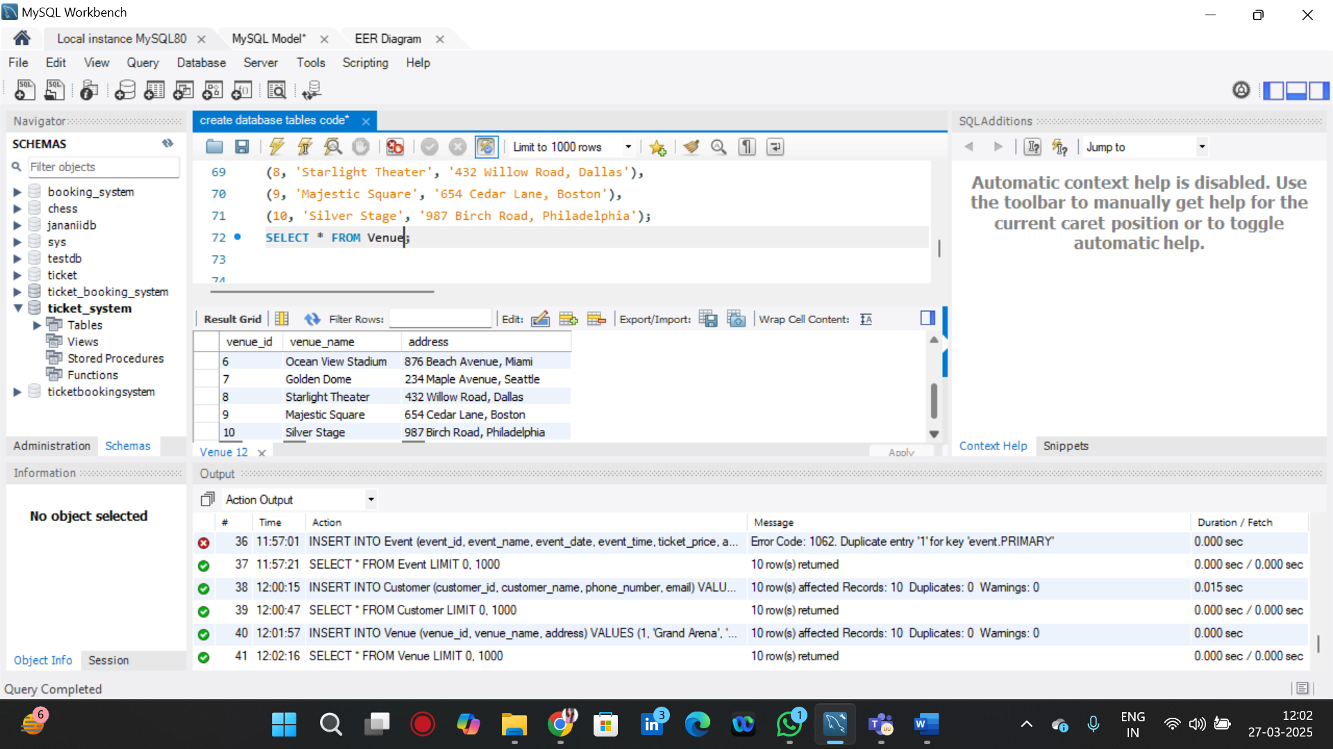

INSERT INTO Booking (booking_id, customer_id, event_id, booked_tickets, booking_date) VALUES

(1, 1, 3, 5, '2025-06-01'),

(2, 2, 5, 2, '2025-07-10'),

(3, 3, 7, 6, '2025-08-15'),

(4, 4, 1, 3, '2025-09-05'),

(5, 5, 9, 7, '2025-10-22'),

(6, 6, 4, 4, '2025-11-30'),

(7, 7, 8, 9, '2025-12-10'),

(8, 8, 2, 3, '2026-01-05'),

(9, 9, 6, 2, '2026-02-15'),

(10, 10, 10, 5, '2026-03-25');

SELECT * FROM Booking;

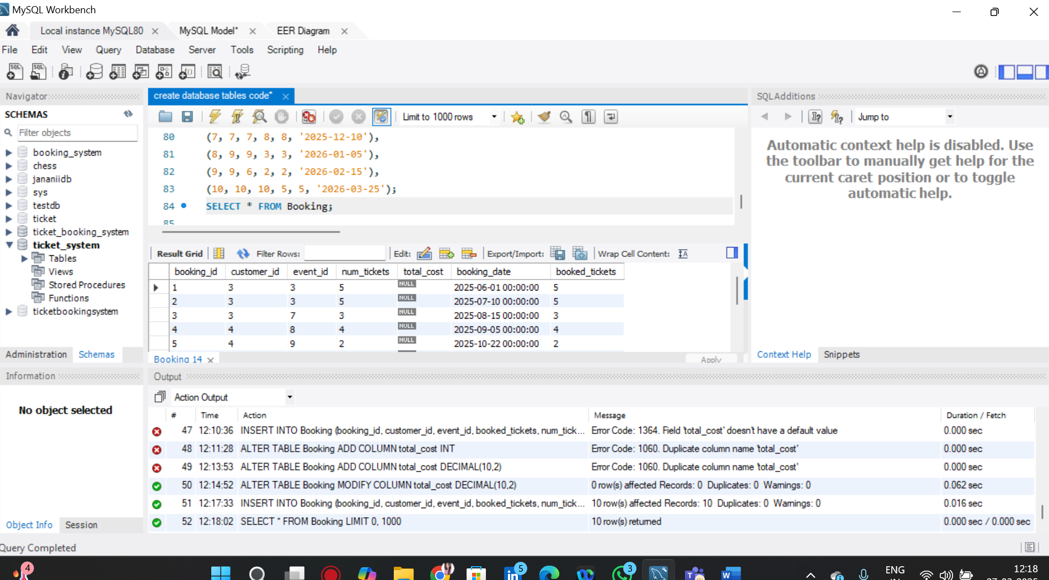

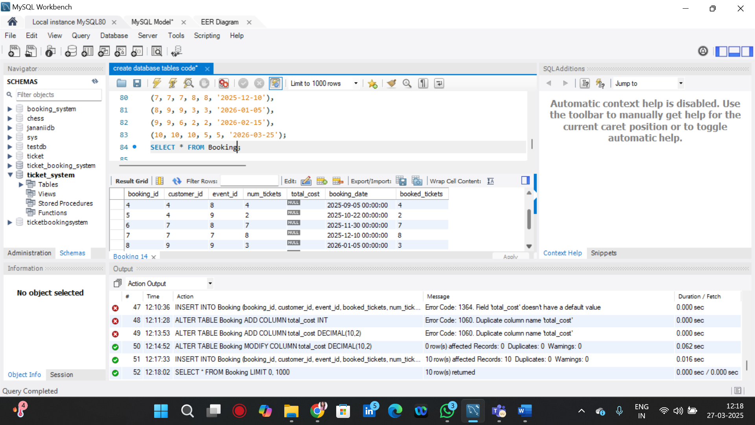

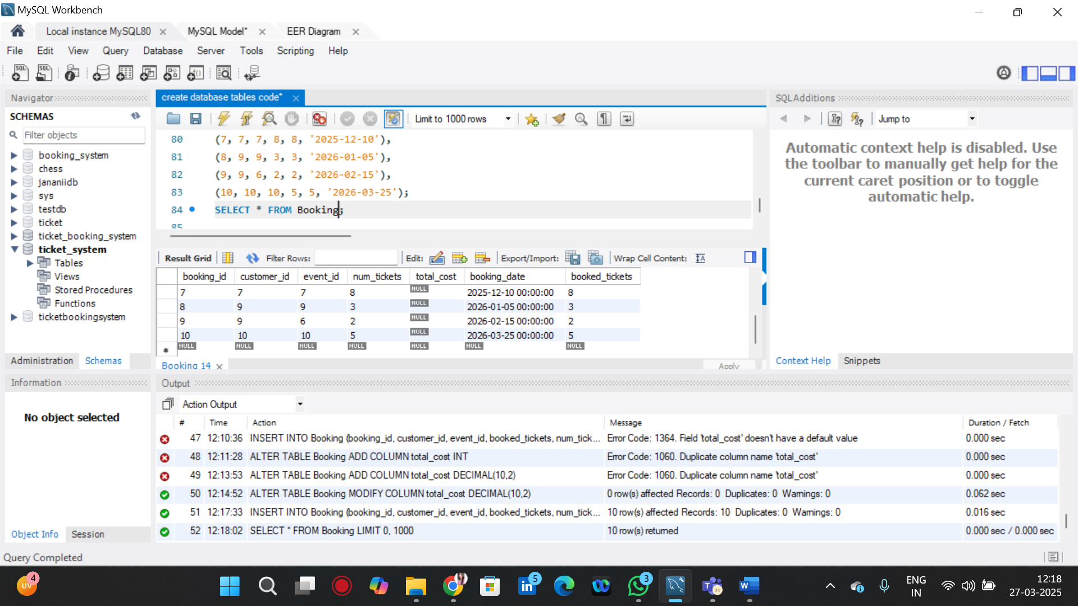

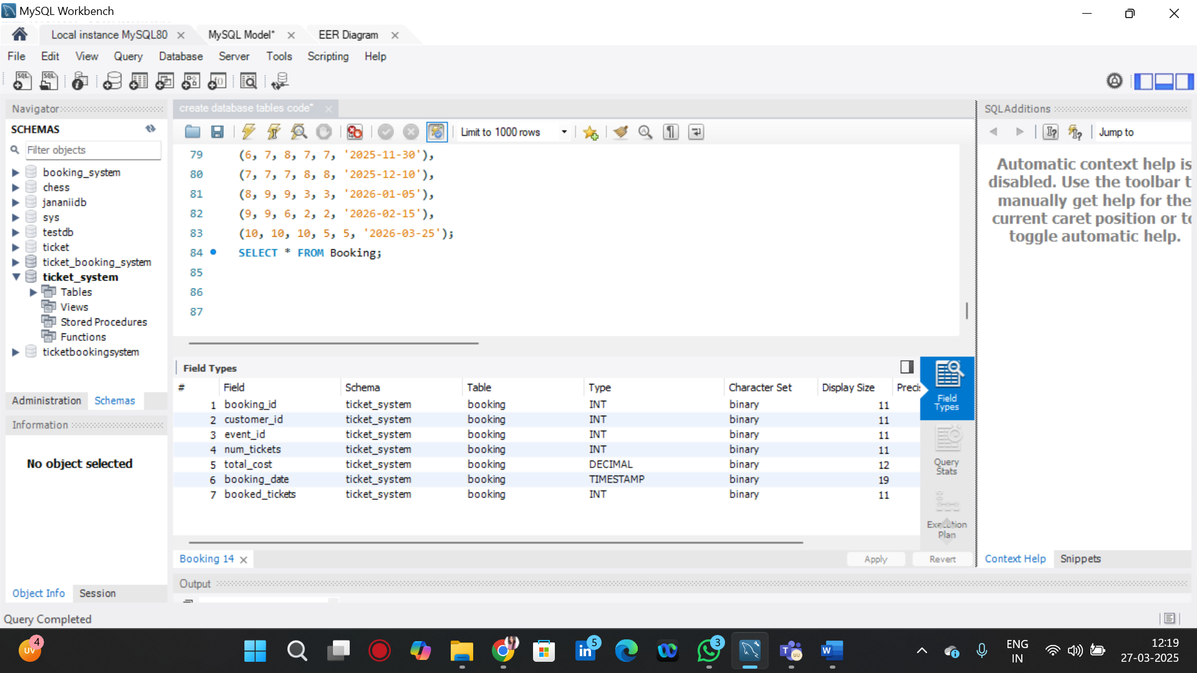

OUTPUT :

